SET LIST

Six Gun Sal will provide its own road crew and techs. No crew services
are required by promotion or purchaser. An experience monitor
engineer and lighting director must be available for any sound checks
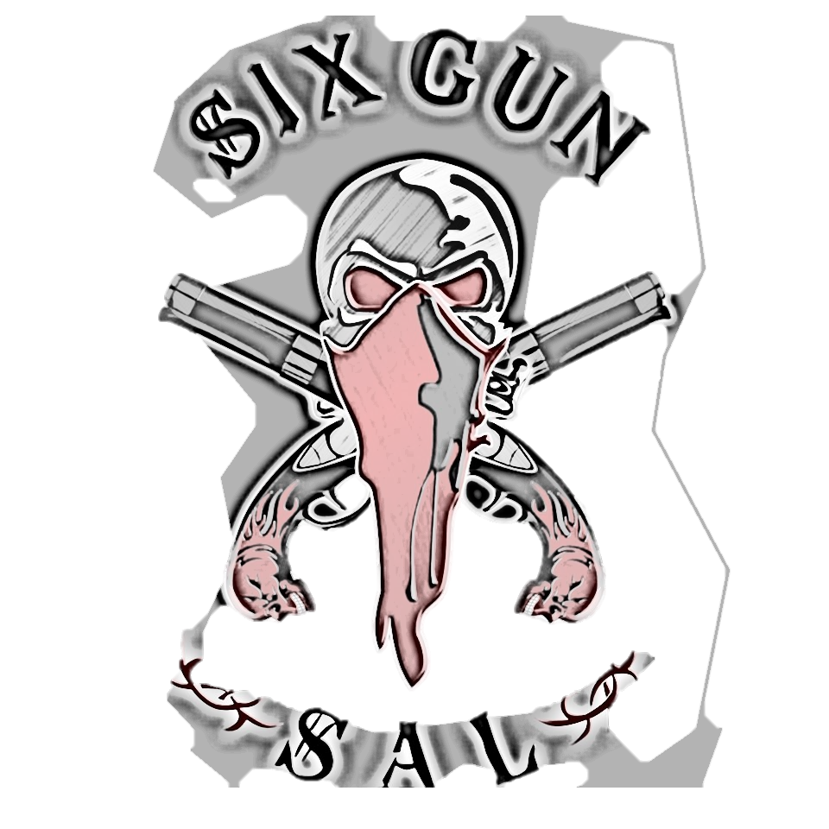
and performance. Six Gun Sal will also supply its own backline.

GUITAR STAGE RIGHT (DUSTY LANG)

(1) BLACKSTAR HT-100 (100 WATT) TUBE HEAD
(1) 4X12 PEAVEY BUTCHER CABINET
(3) 1⁄4 TO 1⁄4 PATCH CABLES
(4) 1⁄4 TO 1⁄4 GUITAR CABLES
(2) GUITAR STANDS FOR CHANGE OUT
(1) IN EAR MONITOR

LEAD GUITAR STAGE RIGHT (ED FIERRO)
(1) MARSHALL JCM 800 TUBE HEAD
(1) MARSHAL 4X12 CABINET
(6) 1⁄4 TO 1⁄4 PATCH CABLES
(4) 1⁄4 TO 1⁄4 GUITAR CABLES
(2) GUITAR STANDS FOR CHANGE OUT
(1) IN-EAR MONITOR

HOUSE MIC AND STAND FOR BACK UPS
LEAD VOCAL CENTER STAGE (TONY APPELLO)

(1) IN-EAR MONITOR
WILL USE HOUSE MIC / AND STANDS
WILL USE HOUSE WEDGES AND SIDE FILLS

STAGE LEFT BASS GUITAR (MATT GEINITZ)

(1) TRAYNOR YBA 200 BASS HEAD
(1) CARVIN 4X10 CABINET
(2) 1⁄4 TO 1⁄4 GUITAR CABLES
(1) IN-EAR MONITORS
HOUSE MIC AND STAND FOR BACKUPS
GUITAR STAGE LEFT (JOE MENDOZA)

(1) MARSHALL JCM 900 TUBE HEAD
(1) 4X12 MARSHALL CABINET
(4) 1⁄4 TO 1⁄4 PATCH CABLES
(2) 1⁄4 TO 1⁄4 GUITAR CABLES
(1) GUITAR STAND
(1) IN-EAR MONITOR

DRUMS (Joey Durant)

(2) 22 INCH BASS DRUMS
(1) 16 INCH FLOOR TOM
(1) 14 INCH FLOOR TOM
(1) 12INCH RACK TOM
(1) 10 INCH RACK TOM
(1) 14 X 8 SNARE
(1) SET 14 INCH HIGH HAT
(1) 2 INCH RIDE CYMBAL
(1) 19 INCH CRASH
(2) 18 INCH CRASH
(1) 17 INCH CRASH
(1) DRUM THRONE
(2) BASS PEDALS
(1) IN-EAR MONITOR

__________________________
Signature of purchaser

__________________________
Signature Six Gun Sal Rep

____________________
Date

